BIOLOGY I
Course Syllabus

Biology 2200  Summer, 2025

Instructor: Mitch Albers, Office S.3330 Science Center
Office Phone (612) 659-6002, E-mail - mitch.albers@minneapolis.edu
Office hours will be held via Zoom on Tuesday and Thursday from Noon – 2 pm, Passcode: 2200
Robert Ruliffson will be your lab instructor and can be reached via Email - robert.ruliffson@minneapolis.edu

Course Website: Please login to D2L to access the course website: https://minneapolis.learn.minnstate.edu/

Semester Credits: 4

MnTC: Goal Area 3

Prerequisite: Introduction to CHEM 1020 or CHEM 1151 High School Chemistry with a Grade of "C" (2.0) or Higher

Textbooks:
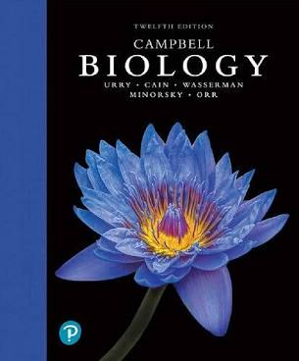    *Required | Campbell Biology* eText by Urry, Cain, Wasserman, Minorsky and Reece. Pearson Publishing Co., 12th ed., 2021. This eTextbook is integrated into your D2L BrightSpace in the “Content””Materials” area. This format is a significant cost savings and is included into your Minneapolis College BIOL 2200 course registration fee.  MasteringBiology (MB) Online Homework* MasteringBiology is now integrated into D2L BrightSpace in the “Content””Materials” area. MasteringBiology Homework will be required for each chapter of the textbook. The cost is included into your Minneapolis College BIOL 2200 course registration fee.  LabArchives Online Laboratory Manual* by Mitch Albers, Students are required to set up an account to download and print weekly laboratory exercises and bring to lab. Students MUST also purchase a 3-ring binder* and maintain a Lab Notebook. See “News” area of D2L for details on how to register your account.  Lab Safety Goggles* On campus lab students only. Can be purchased in the Minneapolis College Bookstore, Home Depot, Menards or Amazon.

Target Population: Those students of any major, but especially biology or related science majors, nursing students and those who need a transferable, lab-science course.

Course Description This course examines the major concepts of biology and is designed for students majoring in Biology, Nursing, and other science related fields. You will gain an understanding of the scientific method, basic biochemistry, cell biology, bioenergetics, reproduction, development, genetics, biotechnology, and evolution. This course includes two hours of required lab per week, which must be taken on campus or online.

Topical Outline:
1. Scientific method and process of science
2. Basic chemistry, organic chemistry and biological molecules
3. Cellular structure and function, membrane transport, metabolism, and division
4. Genetics, DNA and protein synthesis
5. Evolution
Learning Outcomes:
1. Relate principles of chemistry to life and living organisms
2. Understand how cells are organized and function
3. Recognize how the principles of heredity and the environment affect individual organisms
4. Explain the role of evolution in populations
5. Formulate and test hypotheses through hands on laboratory experimentation
Lecture Information:
Instructor lecture support materials for this course will be supplemented via D2L BrightSpace. Lecture presentation materials are provided to you in different formats to support a variety of learning styles. Accessible in the “Materials”“Content” area of D2L.

- Detailed Lecture Notes (DLN’s) with linked Explainer Videos by chapter - Complete lecture notes from your textbook.
- Active Reading Guides (ARG’s) – Complete chapter study guides.
- YouTube Lecture Videos by chapter.
- Prezi Lecture slides (Two versions are available)
- In-Class lecture notes / outlines
- Online Microsoft PowerPoint presentations by chapter.

You will be responsible for information from these resources and the assigned textbook readings. Please spend some time reviewing these resources at the start of the semester. Pick and choose the learning resources that match your learning style best. You might feel a bit overwhelmed at first as you investigate all the learning resources available to you in this course. You do NOT need to use all of them!

Class Requirements:
1. There will be three required lecture exams that will consist of 100 points each. No lecture exams are dropped.
2. The 100 point required final exam will be 50% cumulative and 50% covering chapters 17, 22, & 26.
3. LAB IS REQUIRED. Make sure you have registered for a lab section, and you also MUST attend the lab and complete lab assessments.
4. Weekly MasteringBiology (MB) Textbook Chapter Homework Assignments are required and due every Monday evening at 10:00 p.m. and are calculated into your overall course grade.
5. Lab quizzes and post lab assignments are required and are assigned for each lab and will be due on Sunday evenings at 10:00 p.m.
6. Lecture quizzes and assignments may be given throughout the semester.
7. All students must log into D2L daily and have registered LabArchives and Pearson MasteringBiology (MB) accounts.
8. No audible cellular phones, pagers or smart phones may be accessed on during lecture, lab or during exams. If your personal electronic communication device disrupts class/lab in any way, you will be asked to leave the class/lab for that day which could result in your missing work for credit. Use of these types of devices will be accepted with Learning Catalytic’s in lecture and for certain lab procedures.
9. Student conduct in the course will follow the Minneapolis College Student Handbook.
10. Students must have a registered LabArchives account, and an active MasteringBiology (MB) account set up the first day of the semester.

Grading Standards:
Final semester grades will be calculated by placing your cumulative point total for the semester on a percentage distribution/"curve" for determination of the grade (see “Grading” below). It is important that you keep track of all points earned throughout the semester on your point tally sheet that is included in this syllabus. By dividing the total points, you have earned by the total points possible, you can calculate your percentage (i.e. 585 points earned/600 points possible = 84 % and would be a "B" grade as per the grading scheme outlined below). The following percentages may be adjusted but are provided to give you a sense of where you stand at any one time during the semester.

Grading:
Students must receive a passing grade (70%) in the lecture portion of this course to receive a grade of C or higher in this course. Students who earn less than 70% in the lecture portion of this course, prior to adding the laboratory points to the final grade, will receive a D or F in this course, even if addition of the laboratory grade brings their total percentage above 70%. Passing grades will be determined by percentages (55% = D, 70% = C, 80% =B, 90%=A) of the 600 estimated total points possible scheduled below. Regular class attendance/participation is essential for success in this course, which means unexcused absences from labs will be detrimental to the student’s overall grade. Exam and assignment scores can be viewed by clicking on the "Assessments”Grades" menu in the D2L lecture course web site. No incomplete (I) grades will be given for missed work. Incomplete grades are for someone who has completed all the course for lecture and lab satisfactorily and misses the final exam because of an extended, doctor verified illness or legitimate legal matter.
Note: "Instructors don't give grades, students earn them”
Point Breakdown:
Three Lecture Exams (100 points ea.) 300 points
Final Exam w/50% comprehensive portion 100 points
MasteringBiology (MB) Chapter HW Assignments 50 points (MB grading details posted below)
Lab Quizzes / Post Assignements 100 "percentage" points
Lecture Quizzes (These will be announced in D2L) 50 points
(approx.) 600 total points possible
Note: The above breakdown of points is only an estimate; the actual point total may deviate above or below the points scheduled at this time.

MasteringBiology (MB) Chapter HW Assignments Grading: Your MB total score will be converted to percentage and then divided by 2. For example, if you earned 180 points out of 200 possible (180/200 = 0.9 x 100 = 90% / 2 = 45 Final MB Score). This will be the score used in the final calculation of your overall course grade and it will be posted in your D2L online grade book. Students who score 95% or better on their MB Homework will be able to opt out of taking the optional Adaptive Follow-Up (AFU) and will automatically earn 5 points.
Lab Totals will be determined by percentage points. Weekly lab quiz scores will be posted in the D2L lab course web site and post lab assignment scores in the LabArchives grade books. I reserve the right to alter the course schedule for the duration of the semester, and to alter the points needed for each grade if I deem it necessary.

Academic Integrity: It is important in your learning process to maintain academic integrity. This means completing all assignments independently and taking on-campus/online exams, chapter tests and assignments in good trust (NO CHEATING). By maintaining academic integrity, you will increase your knowledge and skill, while upholding your personal and societal ethical standards. Any student who plagiarizes another student’s work or cheats will either be forced to withdraw or will fail the course…I HAVE A ZERO TOLERANCE RULE. The Minneapolis College Biology Department adheres to the highest standards of academic integrity. Any violations of prohibitions against plagiarism or cheating will be treated with great seriousness, and they risk failure of the course or worse consequences such as expulsion from the college. Consult the Minneapolis College student handbook for advice about avoiding plagiarism/cheating or talk to your instructor about it. If you are aware of any cheating in this course, please contact your instructor. You MUST agree and submit the course Academic Integrity Policy (AIS) form posted in the “Quizzes” area in D2L the first week of the semester in order to continue in this course.

Required Lecture Attendance Policy:
I do not formally take attendance for online lecture portion of this course, but I do have some policies related to attendance that you need to be aware of. I use a variety of learning tools, including group work, electronic student response systems and writing projects. We will use both synchronous (live) and asynchronous (not live) communication in this course, which does not happen in real-time. In other words, we will communicate asynchronously without needing to have a common day / time available for us to meet online. E-mail is an excellent example of asynchronous communication. So are electronic bulletin boards. I WILL EXPECT that you will be logging into both the lecture and lab D2L announcements and checking your E-mail every day (excluding weekends and holidays) and that you’re actively utilizing the online resources in D2L, Pearson MB and LabArchives websites. Announcements regarding the lecture and lab will be posted in the “ANNOUNCEMENTS” area of D2L each week and may be updated throughout the week. Any student attempting to start the online lecture after the drop date will NOT be allowed into the course even if they have registered. If you encounter an emergency that necessitates time away from class, it is your responsibility to contact me immediately and ask for my assistance in planning your return to class and determining the work that needs to be completed. Note: If you need an accommodation due to a learning disability to enable you to fully participate in this course, contact Minneapolis College's Accessibility Resources Center (ARC) office at (612) 659-6730 for assistance.

Required Lecture Exam Attendance Policy:
All lecture exams MUST be completed to pass this course. No lecture exams are dropped, and they all count towards the student’s final course grade. Lecture exams administered in this course will be taken either on campus or online or a combination of both. The instructor has the discretion to determine the testing format/scheduling and will communicate each exams details in the “Announcements” area of D2L. Make-up Lecture Exams: If a student misses a scheduled lecture exam, the student MUST contact the instructor within five calendar days after the scheduled exam date to request approval to take a make-up exam. The timing, format, and content of all make-up exams is at the instructor’s discretion and will differ from the original exam given in class. If approved, all make-up exams will be administered during the last week of the semester prior to the start of Final Exam week and must be taken in the Minneapolis College Accessibility Resources Center (ARC). If a student fails to get approval within the five days after the scheduled exam date, they will receive a zero (0) score for the missing the exam and will have no opportunity to make-up the missed exam up and will either 1.) need to withdraw officially from the course or 2.) will not successfully pass the course.

Required Lab Attendance Policy:
Students who miss more than three labs which means four or more missed lab quizzes in D2L and/or four or more missed post lab assignments in LabArchives will NOT pass the course. Your laboratory experience and attendance/participation are essential for success in this course. The total points available from the lab is approximately 20% of your course grade. Participation in the lab is NOT optional…it is required. Please note that once a scheduled lab quiz or post lab assignment has been missed, they cannot be made-up.

Additional Notes:
1. An option to earn a limited amount of extra credit points will be offered near the end of the semester after the completion of Exam III.
2. Your text, lectures & labs will present biological concepts and principles from an evolutionary perspective the central theme of biology.
3. Some topics of a sexually explicit nature may be covered with aspects of reproduction, gender, meiosis (gametogenesis) and evolution.
4. You will be required to use D2L-BrightSpace the course learning management web site for both the lecture and lab, e-mail, LabArchives online lab manual and Pearson’s MasteringBiology(MB) throughout the semester.

Where to get Help:
If you have questions about the course or if you're struggling with any aspect of it, contact me as soon as possible. Let's talk it over. I can help. Just send me an E-mail or set-up an appointment to meet with me online or in my on-campus office. In addition, the Academic Success Center (ASC), room T3200 on the 3rd floor of the T building is an invaluable resource. Peer tutors are available by appointment to coach you and help you succeed. We will also offer weekly study group workshop sessions via the Academic Success Center. These sessions have been extremely successful to many Biology 1 students. These sessions allow discussions of the course content with fellow classmates and is facilitated by a lead tutor or peer tutor who has already taken the course. To set-up a tutor appointment in the Minneapolis College ASC, phone (612) 659-6140. Mitch will also hold Online Exam Study Sessions and he will post invitations to these Online Study Sessions in D2L.
TEACHING FOR THINKING
Levels of Thinking based on Bloom's Taxonomy

Thinking as to rote memorization is an important part of the learning process. To learn effectively, the learner has to think about the information. The quality on one's thinking can be improved with training. One of the purposes of higher education is to improve the quality of student's thinking. This course will attempt to improve your thinking by requiring you to read, write, ask questions answer questions, work cooperatively with other students, and access a diverse number of electronic learning resources. Why do this? Because your future success in the classroom as well as in your career job will depend on your ability to think critically and solve problems.

When most students are asked, what is thinking?" they are at a loss to speak knowledgeably. You can expect me to attempt to model for you how one goes about thinking about biology during lectures and labs. You will be asked to write responses to questions both individually and collectively in groups. Analysis of your written work is one of the best ways to assess the quality of your thinking. Other ways to assess your thinking are by listening to your answers as well as in the way you solve problems. The exams in this course will attempt to measure how well you have thought about biology. Yes, multiple choice exams can be designed to measure your thinking …here's how.

According to Benjamin Bloom an expert on the psychology of learning, there are six levels of thinking. My lecture exams and pre-lecture question sets are modeled after Bloom's Taxonomy of Higher Thinking. At each level there are key words that identify the level of thinking. Every question in my exams, quizzes, assignments also utilize these key words and allow you to identify the level your thinking should be at.

- Remembering Level: This includes rote recall and recognition of facts. Questions that ask you to match terms with their definitions are at this level of thinking. Questions which are asked during exams which test at this level are the "Who?", "What?", "Where?", and "When?" types of questions. Others will ask you to "List", "Identify", "Name", or "State" things. What is the author saying? is another example of a question that asks you to remember.
- Understanding Level: This results from simple information processing. This second level of thinking is being tested when questions use words and phrases such as "Restate in your own words", "Explain", "Describe", "Illustrate", "Give an Example". "Summarize", "What are the generalizations?", "What are the conclusions?" or simply "Why?" and "How?"
- Applying Level: At this level of thinking one learns a concept in one context and is asked to apply it in another. Questions which test at the application level ask you to "Solve a problem or issue", "Relate", "Associate", "Illustrate", "Demonstrate", or "Calculate". They also ask "What is your opinion?" and "What do you think?"
- Analyzing Level: Here the thinker seeks deeper meanings, relationships or structure. Questions at this level of thinking ask you to "Break Down, into parts and examine each part", "Perceive the underlying assumptions", "Trace the reasoning", "Note the fallacies", "Inspect", "Classify", "Generalize", "Note cause and effect relationships", or "Compare". They also can ask, "What are the inferences?" or "What are the author's biases?"
- Evaluating Level: This type of thinking requires personal reactions. It involves the thought process working in conjunction with the emotional components that affect the thought process. "Evaluate", Assess", "Value", and "Appreciate" indicate this sixth, and highest level of thinking. "Why is it good?", "Why is it bad?", "What is the worth of it?" and "How would you react?" are all questions which deal with evaluation.
- Creating Level: Creative thinking involves all of the other levels. In the creative process the student/s, remembers, understands & applies knowledge, analyses and evaluates outcomes, results, successes and failures as well as processes to produce a final product. The following are some of the key terms for this aspect of the Taxonomy. “Designing”, “Constructing”, “Planning”, “Producing”, “Inventing”, “Devising”, and “Making” are all key terms that identify the creating level of thinking skills.

One of the purposes of the proceeding discussion is to help you plan for learning materials (processing the information) in biology. Use Bloom's Taxonomy of Thinking to focus your attention as you study the principles of biology. My homework, quizzes and exams will test you at all six levels, but more frequently at levels 1-3. Understanding Bloom's Taxonomy will give you greater control in your ability to think. More control on your thinking will reduce your anxiety and make you a more efficient learner for greater success.

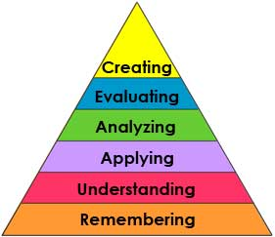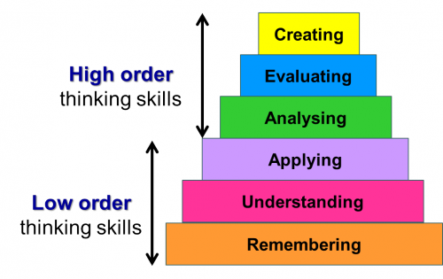

Please Note: All the Biology 1 lecture and lab course assignments, quizzes, and exams are created and based off the above Bloom’s Taxonomy Thinking Model. It is at the core of how I teach in all aspects of the Biology 1 course. How can you utilize Bloom’s Taxonomy in other courses and your daily life?

Give Bloom's Taxonomy a try…it can make you more successful in this course!
Biology 1
Tentative Lecture Schedule
Online | Hybrid Sections
Summer Semester 2025 | Minneapolis College
--Lecture Schedule subject to change--

_Week__________________Dates__________________Topics________________________Text Readings__MasteringBiology (MB) Homework_
01 June 16 – 22 Introduction to the course Syllabus
Using the Internet & Course Web Site Intro to MB Due 10 p.m. 6-23-25
Themes in the Study of Life Ch. 1 pp. 2 – 26 Ch 1 Due 10 p.m. 6-23-25
The Chemistry of Life Ch. 2 pp. 28 – 43 Ch 2 Due 10 p.m. 6-23-25
---------------------------------------------------------------------------------------------------------------------------------------------------------------
02 June 23 - 29 Water & Life Ch. 3 pp. 44 - 55 Ch 3 Due 10 p.m. 6-30-25
Carbon & Molecular Diversity of Life Ch. 4 pp. 56 – 65 Ch 4 Due 10 p.m. 6-30-25
Structure & Function of Lg Biological Mole Ch. 5 pp.66 – 91 Ch 5 Due 10 p.m. 6-30-25
---------------------------------------------------------------------------------------------------------------------------------------------------------------
03 June 30 – July 6 EXAM I (Exam I covers Ch’s 1, 2, 3, 4 & 5) Will BE TAKEN ONLINE (D2L) June 30
A Tour of the Cell Ch. 6 pp. 93 – 125 Ch 6 Due 10 p.m. 7-7-25
Membrane Structure & Function Ch. 7 pp. 126 – 142 Ch 7 Due 10 p.m. 7-7-25
Introduction to Metabolism Ch. 8 pp. 143 – 163 Ch 8 Due 10 p.m. 7-7-25
--------------------------------------------------------------------------------------------------------------------------------------------------------------
04 July 7 – 13 Cellular Respiration & Fermentation Ch. 9 pp. 164 – 186 Ch 9 Due 10 p.m. 7-14-25
Photosynthesis (Not covered on Exam II) Ch 10 pp. 187 – 211 Ch 10 Due 10 p.m. 7-14-25
--------------------------------------------------------------------------------------------------------------------------------------------------------------
05 July 14 –20 EXAM II (Exam II covers Ch’s 6, 7, 8, & 9) Will BE TAKEN ONLINE (D2L) July 14
The Cell Cycle Ch. 12 pp. 234 – 252 Ch 12 Due 10 p.m. 7-21-25
Meiosis & Sexual Life Cycles Ch. 13 pp. 254 – 268 Ch 13 Due 10 p.m. 7-21-25
Mendel and the Gene Idea Ch. 14 pp. 269 – 293 Ch 14 Due 10 p.m. 7-21-25
--------------------------------------------------------------------------------------------------------------------------------------------------------------
06 July 21 - 27 The Chromosomal Basis of Inheritance Ch. 15 pp. 294 – 313 Ch 15 Due 10 p.m. 7-28-25
The Molecular basis of Inheritance Ch. 16 pp. 314 – 334 Ch 16 Due 10 p.m. 7-28-25
From Gene to Protein Ch .17 pp. 335 – 363 Ch 17 Due 10 p.m. 7-28-25
--------------------------------------------------------------------------------------------------------------------------------------------------------------
07 July 28 – Aug 3 EXAM III (Exam III covers Ch’s 12-15 & 16) Will BE TAKEN ONLINE (D2L) July 28
Decent with Modification: Darwin Ch. 22 pp. 468 – 485 Ch 22 Due 10 p.m. 8-1-25
Tracing Phylogeny and the Tree of Life Ch. 26 pp. 553 – 572 Ch 26 Due 10 p.m. 8-1-25
--------------------------------------------------------------------------------------------------------------------------------------------------------------
FINAL August 04 Final Exam Testing Details and Info will be posted in Course Website (D2L)
EXAMINATION 50% Cumulative, 50% will cover Chapters 17, 22, & 26)

HAVE A CHALLENGING AND REWARDING SUMMER SEMESTER!


Biology 1
Tentative Laboratory Schedule
All Sections
Summer Semester 2025 | Minneapolis College
--Lab Schedule subject to change--

Lab Instructors: Mitch Albers (Online) & Rob Ruliffson (On Campus)

_Week_________________________________Lab Topics______________________ LabArchives Post Lab Assign & D2L Lab Quiz_
01 June 17 Introduction to the lab Lab Syllabus
Laboratory Safety Exercise A 10 pm 6-22-25
Start Genetics Experiment Exercise 9
June 19 (Holiday) Scientific Inv. (All Students will do Online Lab) Exercise 1 10 pm 6-22-25
----------------------------------------------------------------------------------------------------------------------------------------------------
02 June 24 Chemistry of Life Exercise 2 10 pm 6-29-25
June 26 Biological Molecules Exercise 3 10 pm 6-29-25
----------------------------------------------------------------------------------------------------------------------------------------------------
03 July 1 The Microscope Exercise 4 10 pm 7-6-25
July 3 No Lab Meeting for 4th of July Holiday
----------------------------------------------------------------------------------------------------------------------------------------------------
04 July 8 Cell Structure and Function Exercise 5 10 pm 7-13-25
Mid Term – 3 Ring Binder Lab Manual Check 7/8 for on campus 10 pm 7-13-25 online
July 10 Cellular Respiration Exercise 7 10 pm 7-13-25
----------------------------------------------------------------------------------------------------------------------------------------------------
05 July 15 Cellular Division - Mitosis Exercise 8 10 pm 7-20-25
July 17 Cellular Division - Meiosis Exercise 8 10 pm 7-20-25
----------------------------------------------------------------------------------------------------------------------------------------------------
06 July 22 Mendelian Genetics (Chi Square Analysis) Exercise 9 10 pm 7-27-25
July 24 DNA Cloning (Bacterial Transformation) Exercise 10 10 pm 7-27-25
----------------------------------------------------------------------------------------------------------------------------------------------------
07 July 29 Electrophoresis (DNA Fingerprinting) Exercise 11 10 pm 8-1-25
July 31 Taxonomy Exercise 13 10 pm 8-1-25
End of Term – 3 Ring Binder Lab Manual Check 7/31 for on campus 10 pm 8-1-25 online
----------------------------------------------------------------------------------------------------------------------------------------------------

Lab Notes:
- All students are REQUIRED to purchase a $20 LabArchives online lab manual account. See Lab D2L Announcements for details on registering your account.
- Students who complete lab quizzes in D2L without doing the actual lab exercises in LabArchives will be null and void and students who do not register a full-fledged, active working LabArchives account after missing more than three labs for the semester will be either LDA’d from the course and or not pass the course as per the Lab Attendance and Last Date of Attendance Policies.
- All online and on campus lab exercises will be conducted using the online LabArchives lab manual.
- Students must complete the assigned weekly lab exercise, lab quiz and post lab assignment by 10:00 p.m. on Sunday evenings.
- All post lab assessments must be completed and submitted in the LabArchives website by the 10:00 pm Sunday deadline.
- All lab quizzes must be completed in the “Assessments”→”Quizzes” area of the Lab D2L website by the 10:00 pm Sunday deadline.
- Lab quizzes and post lab assignments CANNOT be made-up if not completed by the Sunday 10:00 p.m. deadline.
- Students who miss more than three labs which means four or more missed lab quizzes in D2L and/or four or more missed post lab assignments in LabArchives will NOT pass the course. They will need to withdraw before the drop date or will fail the course.
- The Lab is a REQUIRED learning experience and assessment for the Biology 1 course.
- Students MUST follow to all lab safety polices / procedures outlined in the LabArchives BIOL 2200 Online lab manual.

Biology 1 Required Websites:

The Biology1course requires you to log into the following four websites to do the lecture and lab portions of the course. It is your responsibility to log into these websites often (daily) to ensure you are aware of all required course deadlines and communications.
D2L Lecture  BIOL 2200 All Sections | MasteringBiology (MB)  Pearson's MasteringBiology (MB) | D2L Lab  BIOL 2200 Labs Combined | LabArchives  Biology 1 Lab Manual
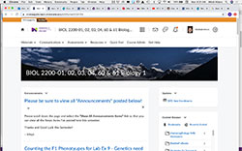 | 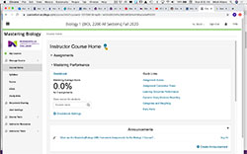 | 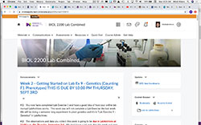 | 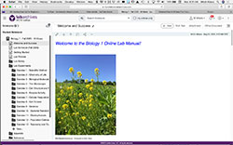
NOTE: All Lecture Communications / Announcements Posted here in D2L.  D2L-->Materais-->Contents  Lecture Resources:  - Access to eText  - Access to MB  - Strategies for Success  - Mitch's YouTube Video Lectures  - Mitch's Detailed Lecture Notes (DLN)  - Mitch’s Active Reading Guides (ARG’s)  - Mitch's PowerPoint Lecture Slides  - Mitch's Prezi Lectures  - Vocabulary Flash Cards  - Textbook Glossary  - Wood Roots  Exam Prep Resources:  - Chapter Pre-Tests  - Chapter Post-Tests  - Cumulative Test (Practice Exams)  - Explainer Videos  D2L-->Assessments-->Quizzes  - Lecture Exams  - Lecture Quizzes | Lecture Homework Assignments by Campbell’s “Biology” textbook, 12th ed. chapters:  - MB Homework Assignments (Due Monday’s 10:00 p.m.  - Optional AFU’s - Due Tuesday’s 10:00 p.m.  Study Area:  - Study by Chapter  - Access to eText  - Get Ready for this Chapter  - Practice Tests  - Cumulative Test  - Figure Walkthroughs  - BioFlix 3D Animations  - HHMI BioInteractive Videos  - GraphIt  - Current Events  - Vocabulary Study Tools  - Additional Resources  MB Technical Support: If you are experiencing any registration or web browser issues, please contact Pearson Mastering Support at the following URL’s:  - Student Support  - Browser Support  Please do NOT contact your instructor with these technical support issues. | NOTE: All Lab related Announcements will be posted your Lab D2L Website on Sunday’s each week.  D2L-->Assessments-->Quizzes  - Lab Quizzes take here  - Due Sunday’s 10:00 p.m.  - Please read Lab Attendance Policy Carefully as Lab is a REQUIRED experience / assessment component of this course.  D2L BrightSpace Login URL:  - Click Here  D2L Support URL:  - Click Here  Please do NOT contact your instructor with these issues. | Online Lab Manual: REQUIRED  Student must register their own LabArchives accounts for $20 using a credit card. Registration URL is posted in your D2L Lab Website.  - Pre-Lab Reading  - Pre-Lab Assignment  - Lab Activities  - Post Lab Assignments  - (Due Sunday’s 10:00 p.m.)  - All Post Lab Assignments are turned in online in LabArchives.  - Post Lab Assignments turned in via e-mail or hardcopy will NOT be accepted.  - Please read Lab Attendance Policy Carefully as Lab is a REQUIRED experience / assessment component of this course.  LabArchives How to Guide:  - Quick Start Guide  LabArchives Technical Support: If you are experiencing any registration or web browser issues, please contact LabArchives Support at the following URL’s:  - Student Support  - Browser Support  Please do NOT contact your instructor with these technical support issues.
Biology 1 Weekly Schedule:

Every Sunday I’ll post my Weekly Announcements in the Lecture and Lab D2L websites noting the following:

Sunday’s – Lab Assessments Deadline
- Weekly Lab Exercise Post Lab Assignment submitted in LabArchives due at 10 pm (see lab schedule above)
- Weekly Lab Quiz completed in D2L website for Lab due at 10 pm. (see lab schedule below)

Monday’s – MasteringBiology (MB) Deadline
- Completed scheduled MasteringBiology (MB) Homework Assignments due at 10 pm (see lecture schedule above)
- Mitch’s Office Hour - Noon-1 pm in S.1200 lab
Tuesday’s
- Attend On Campus Lab Sections 60 and 61 meet in the S.1200
- 100% OPTIONAL Adaptive Follow-Up (AFU) MasteringBiology (MB) Homework Assignments due at 10 pm
- Mitch’s Office Hour – Noon-1 pm via Zoom Use Passcode: 2200
- Online Lab Sections 80 & 81 should strive to complete online lab exercises by Friday each week.

Wednesday’s
- Mitch’s Office Hour - Noon-1 pm in S.1200 lab

Thursday’s
- Attend On Campus Lab Sections 60 and 61 meet in the S.1200
- Mitch’s Office Hour – Noon-1 pm via Zoom Use Passcode: 2200
- Online Lab Sections 80& 81 should strive to complete online lab exercises by Friday each week.

**Always pay attention for other posted course deadlines & READ all Announcements posted in D2L daily**

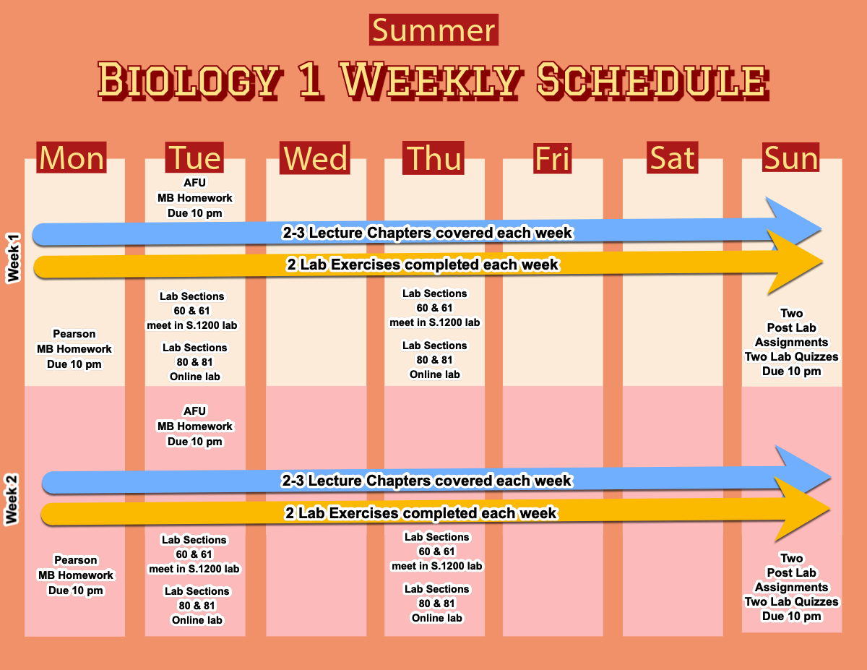
Example of typical Summer 2025 Semester Weekly Biology 1 Schedule and Deadlines
WHAT is REQUIRED and EXPECTED by the BIOLOGY 1 STUDENT each WEEK:

You are REQUIRED to do the following two tasks:

- Master the Biology 1 Vocabulary Terms covered in each textbook chapter.
- Understand the Concepts and Principles of Biology covered in each textbook chapter.

You are EXPECTED to do the following in order to master the above two tasks:

- Read the assigned textbook reading listed in the Lecture Schedule on page 5 of this syllabus.
  - Use the Active Reading Method 3x per chapter reading for each textbook chapter.
    - 1st – Skim the chapter for major themes covered and visuals
    - 2nd – Write out Vocabulary Cards to practice learning vocabulary
    - 3rd – Sit down and read word-for-word – reading will flow and you won’t get bogged down with info overload.
- Annotate the Detailed Lecture Notes (DLN’s) as you work through each chapter
- View Mitch’s YouTube Chapter Lecture Videos.
- Utilize Active Studying strategies / methods to learn / understand the Biology 1 vocabulary terms and concepts
  - Complete Mitch’s Active Reading Guides (ARG’s) – These become amazing Study Guides for the lecture exams.
  - Participate in the Academic Success Center (ASC) Workshops
  - Form a peer study group or partner
  - Meet and complete the Monday 10 pm deadlines for MasteringBiology (MB) Homework Assignments.
- Actively attend lab and complete the weekly lab Sunday 10 pm Deadlines for Post Lab Assignments and Lab Quizzes.
- Participate in the scheduled office hours and Lecture Exam Study Sessions.

Biology 1 – Instructor’s Lecture Resources:
DLN = Detailed Lecture Notes Directory Homepage – Links provided to these lecture resources in D2L
My Detailed Lecture Notes (DLN's) come in two versions, 1.) Print with links to explainer videos and 2.) Enhanced (DLN EN) version with images and links to explainer videos specifically for students using smart phones, tablets and PC's to study with. Students bring the printed version of the DLN's to lecture class and mark-up these lecture outlines during the lecture presentations. Online students also do the same while viewing my YouTube lecture videos.
ARG = Active Reading Guides Directory Homepage - Links provided to these lecture resources in D2L
My Active Reading Guides come in two versions, 1.) Print version and 2.) Enhanced (ARG EN) version with images and links to explainer videos specifically for students using smart phones, tablets and PC's to study with. These promote active learning of the Biology 1 course concepts and principles and utilize active learning strategies to help students remember, understand and learn the chapter concepts in a more efficient ways. These ARG's when completed make tremendous study guides for each chapter. Both my DLN's and ARG's are found in the "Materials"-->"Content" area of D2L
CHAPTER | DLN PRINT | DLN EN | LECTURE VIDEO | ARG PRINT | ARG EN
01 - Intro to Biology | Click here | Click here | Click here | Click here | Click here
02 - Chemistry | Click here | Click here | Click here | Click here | Click here
03 - Water | Click here | Click here | Click here | Click here | Click here
04 - Carbon Chemistry | Click here | Click here | Click here | Click here | Click here
05 - Macromolecules | Click here | Click here | Click here | Click here | Click here
06 - Cells | Click here | Click here | Click here Part 1 Part 2 Part 3 | Click here | Click here
07 - Cell Membranes | Click here | Click here | Click here | Click here | Click here
08 - Intro to Metabolism | Click here | Click here | Click here Part 1 Part 2 | Click here | Click here
09 - Cellular Respiration | Click here | Click here | Click here Part 1 Part 2 Part 3 Part 4 Part 5 Part 6 | Click here | Click here
10 - Photosynthesis | Click here | Click here | Click here | Click here | Click here
12 - Mitosis | Click here | Click here | Click here | Click here | Click here
13 - Meiosis | Click here | Click here | Click here | Click here | Click here
14 - Mendelian Genetics | Click here | Click here | Click here | Click here | Click here
15 - Chromosomes | Click here | Click here | Click here | Click here | Click here
16 - DNA - Replication | Click here | Click here | Click here | Click here | Click here
17 - Protein Synthesis | Click here | Click here | Click here Part 1 Part 2 | Click here | Click here
22 - Darwin - Evolution | Click here | Click here | Click here | Click here | Click here
26 - Phylogeny - Taxonomy | Click here | Click here | Click here | Click here | Click here
How the Biology 1 Lab Exercises are to be completed each week in LabArchives:

The D2L Lab website is where I'll be posting your Lab Grade Book and where you'll find announcements for each weeks Online Lab Exercises and Quizzes.
LabArchives Online Lab Manual:
The required online Lab Manual is called LabArchives and is a separate website from D2L. You will be using LabArchives to work through the lab activities and to submit your Post Lab Assignments for grading each week. Details about LabArchives and how to register your $20 LabArchives account are posted in the announcements area of your D2L Lab Website.
The below annotated image of Lab Exercise 1 - Scientific Investigation describes all the LabArchives online lab manual menu features.
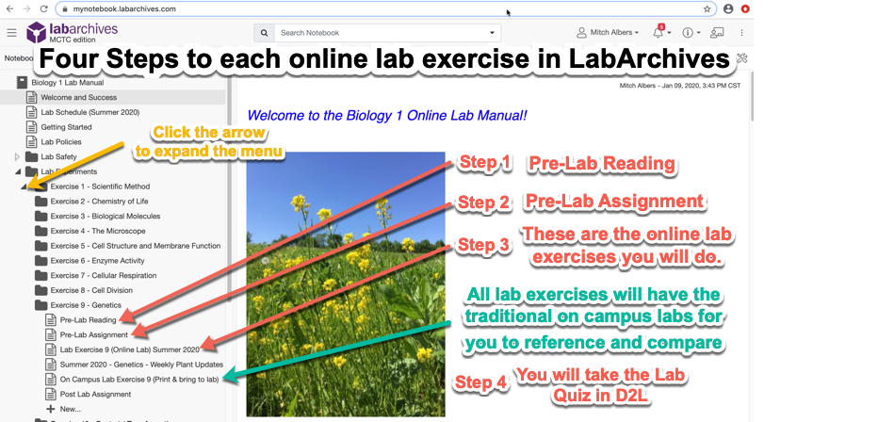

ONLINE LAB EXERCISE 9 (GENETICS) ** EXAMPLE BELOW **
The weekly labs will be completed in the following four steps:
Step 1: Pre-Lab Reading
- Students need to read the Pre-Lab Reading Lab Exercise 9 (Genetics) articles posted for each lab.
Step 2: Pre-Lab Assignment
- Students need to work through and complete the Pre-Lab Assignment(s) for Lab Exercise 9 (Genetics).
- NOTE: You will NOT turn these in to be graded by will be quizzed on them.
Step 3: Online Lab Exercise(s)
- Students need to print hardcopies of these and work through the online Lab Exercise 9 (Genetics).
  - Online Genetics Activity 1 - Chi Square Test in action
  - Online Genetics Activity 2 - Results and Discussion of Mendelian Dihybrid Cross of Brasica rapa (wild mustard) plants
  - The printed hardcopies of each lab are to be organized into a 3-ring binder each week.
Step 4: Lab Quiz
- Students need to complete the online Lab Exercise 9 quiz in the "Assessments"-->"Quizzes" area of your "lab D2L website" by 10:00 pm Sunday following the scheduled lab.
- Weekly Lab Quiz questions will be generated from each lab's Pre-Lab Reading, Pre-Lab Assignment and Online Lab Exercise(s).
Additional Biology 1 Course Policies / Information:

Important Last Date of Attendance (LDA) Policy for Students

Last Date of Attendance (LDA) Policy for Minneapolis College can be viewed at this URL: https://minneapolis.edu/about-us/policies/procedure-41601

PART 1. PURPOSE
The purpose of this procedure is to define the process for reporting changes in enrollment that meets the federal regulations 34 CFR 668.22 – Treatment of Title IV Funds, for institutions that administer federal financial aid. Instructors must report Last Date of Attendance (LDA) information for students who never attended or who stopped attending but did not withdraw from the course during the semester or term.

PART 2. DEFINITIONS
Academic Engagement: Any student activity that relates to the academic content of the course, including attending a class session, completing assignments or exams, or participating in discussion posts. Logging into a course does not constitute academic engagement.
Never Attended: A specific grade used by the college to report students enrolled in their courses that have not conducted any academic activity during the course.
Never Withdrew: A specific grade used by the college to report students who stopped participating in academic activities for the period outlined in Part 4.
Short-term Courses: Courses that span less than the full 17-week semester.

PART 3. NON-PARTICIPATION WINDOWS LEADING TO LAST DATE OF ATTENDANCE REPORTING
The following are the time periods that trigger the need for faculty to report “LDAs” based on the length of the course:
- For classes that are 1-2 weeks in duration: report LDA after 2 business days with no academic engagement by the student
- For classes that are 3-6 weeks in duration: report LDA after 3 business days with no academic engagement by the student
- For classes of 7-8 weeks in duration: report LDA after 5 business days with no academic engagement by the student
- For classes of 9 or more weeks in duration: report LDA after 10 business days with no academic engagement by the student

PART 4. PROCEDURES FOR FACULTY TO REPORT LAST DATE OF ATTENDANCE

Subpart A. Never Attended
Faculty must report a grade of “NA” (Never Attended) for students who enrolled in a course and failed to engage in any academic activities within the first 10 business days of the semester. (For classes that start after the beginning of the semester, faculty must report a grade of “NA” within the first 10 business days of the course.)
Deadlines for faculty to report a “NA:”
- For courses that begin at the start of a semester: No later than 11:59 pm on Tuesday of the third week of the semester.
- For all other courses: No later than 10 calendar days after the non-participation window outlined in Part 3.

Logging into D2L does NOT mean you are active in the course. Student activity will be based on the student completing MasteringBiology (MB) homework assignments, Lecture Exams, Lab Quizzes and Post Lab Assignments by the posted deadlines. A students LDA will be based on the completion of one of the required Biology 1 courses assessments.

Students who complete lab quizzes in D2L without doing the actual lab exercises in LabArchives will be null and void and students who do not register a full-fledged, active working LabArchives account after missing more than three labs for the semester will be either LDA’d from the course and or not pass the course as per the Lab Attendance Policy outlined above.
Course Communications &Frequency E-mail will be checked by the Instructor:

All course communications will be posted in the “News” area of D2L. I will post weekly updates each Sunday evening about the upcoming weeks events in the course. Students are responsible for checking the course syllabus and News area in D2L on a regular basis to make sure they are up to date on what is happening in the course.

I will only send you an E-mail in an emergency, otherwise I’ll only use E-mail to respond to your questions that are sent directly to my Minneapolis College E-mail address.

I generally check my E-mail numerous times every day. I will try to respond to your questions as soon as possible. Be aware that I may not respond to your E-mail for a day or two. I do check messages on weekends at times, but don't expect that I will respond to messages sent on a weekend or holiday. I may not respond to certain questions that can be easily answered from information provided in your course syllabus or in the announcements area of D2L.

My e-mail address: mitch.albers@minneapolis.edu

Guidelines for Sending E-mail Communications to your Instructor:
If you need to send me an e-mail for any reason about this course you MUST include the following information:
- Include your full First and Last names as they are listed in the course roster in D2L. I will NOT respond to any e-mail messages that do not include your full name in them.
- Include the topic of your e-mail in the "subject line" of your message. I will NOT open any e-mails without the subject line being included in the message.
- You need to write complete sentences, with proper punctuation, spelling and grammar. NO text abbreviations please!

Course Access and Success:

I am committed to creating a course that is inclusive in its design.

If you encounter barriers, please let me know immediately so that we can determine if there is a design adjustment that can be made to overcome the limitations of the design. I am always happy to consider creative solutions if they do not compromise the intent of the assessment or learning activity. I welcome feedback that will assist me in improving the usability and experience for all students.

You are also welcomed to contact the Accessibility Resource Center to begin this conversation or to establish accommodations for this or other courses. The Accessibility Resource Center (ARC) is here to remove barriers for students who:
- experience stress and anxiety related to academics,
- struggle with attention and focus,
- have mental health concerns that impact school,
- use assistive and/or adaptive technologies,
- had an IEP or a 504 Plan in high school, and/or
- identify as a person with a disability.
The ARC:
The Accessibility Resource Center (ARC) is the office designated to work with students with disabilities to determine and facilitate reasonable and appropriate accommodations.
- connects students, faculty, and staff to appropriate resources,
- coach’s students on how to work through challenges,
- builds advocacy skills,
- ensures equitable access, and
- proctors all instructor arranged make-up testing and testing accommodations.
For more information visit Accessibility Resource Center. (Or go to minneapolis.edu > “Students” in upper right > Student Support Services > Accessibility Resource Center.
- Email: accessibility@minneapolis.edu
- Phone: 612-659-6730

Veterans and Active Military Members:

Minneapolis College is dedicated to assisting veterans and eligible family members in achieving their educational goals. Military members who are currently serving should advise their instructor of all regularly scheduled military training and duties that conflict with scheduled course requirements. Instructors will work with the student to address issues that arise. For further information on this, refer to Minnesota State Procedure 5.12.1 Military Service and Disabled Veterans.

Religious Observation:

Minneapolis College is dedicated to our core values of diversity and inclusion, including non-discrimination based on religion. Please provide reasonable notice (ten days) of the dates of religious holidays on which you will be absent. Absence from classes or examinations for religious reasons does not relieve you from responsibility for any part of the course work required during the period of absence, but it is my responsibility to make reasonable accommodations, In accordance with College Policy 2.07, so you do not need to choose between religious observance and academic work. Note that to receive this accommodation, it is important that you request it from me “within a reasonable time (ten days) before the needed accommodation,” as stated in the policy.

Removing Barriers for Lack of Basic Needs:

If you face challenges securing food or housing and this is affecting your performance in your courses, consider contacting the Student Support Center. If you’re comfortable letting me know as well, I may be able to connect you with additional resources.

Academic Advising:
A strong partnership with an academic advisor will help you to navigate the college, understand program requirements and develop your education plan. We are here to get you to get you there! Academic Advising Appointments: Schedule through Navigate

Click here for more information above Academic Advising.

Additional Minneapolis College Campus Student Resources:

The following links provide student information about resources available to you here at Minneapolis College campus. You will find links to a variety of campus resources below. Click here for all Student Support Services for Spring Semester 2024
Academic Success Center
Accessibility Resource Center (ARC)
African American Education Empowerment Program
American Indian Success Program (Unite)
Collegiate Recovery Program
Information Technology Services
LUCHA (Latinos Unidos for College and Higher Achievement)
Minneapolis College Library
Minneapolis College Store
Navigate
Student Support Center
Student Health Clinic
TRIO / Starting Point
Veterans Services

Verification of My Biology 1 Course Section:

Check your official spring schedule you received after registering for your Summer Semester 2025 courses.
My official Biology 1 Course Section for Summer 2025 is: BIOL 2200-____ and I am in the (circle one) On Campus Lab or Online Lab (see table below)

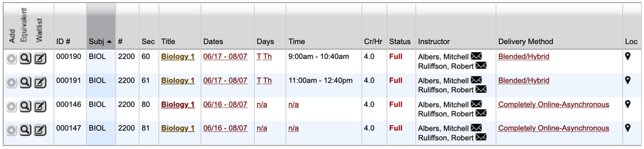

Student Code of Conduct Standard, :The Student Code of Conduct”:

Minneapolis College encourages students to be respectful, considerate, and responsible learners who contribute to the learning community at the College. All Minneapolis College students are expected to have familiarity with, and abide by, college rules and regulations governing personal conduct, such as this policy. Any student found to have committed or to have attempted to commit any of the following acts of misconduct in circumstances falling under the jurisdiction of this code may be subject to the disciplinary sanctions:
Dishonesty, including, but not limited to academic dishonesty (such as cheating and plagiarism), or knowingly furnishing false information to the College.
- Plagiarism includes, but is not limited to: The use of, by paraphrase or direct quotation, the published or unpublished work of another person without full and clear acknowledgment, or Unacknowledged use of materials prepared by another person or agency engaging in selling or otherwise providing term papers or other academic materials. This includes students sharing any information about Biology 1 lecture and lab assignments, quizzes and exams in any form.
- Artificial intelligence (AI) technology (such as generative AI) may not be used by Biology 1 students to generate content for any Biology 1 course assessments (post lab assignments, lab quizzes, lecture assignments and lecture exams), in whole or in part, or other coursework unless approved by the instructor.
- All Biology 1 students MUST follow the full Minneapolis College Student Code of Conduct Policy 4.04. Click here to view complete policy.

About your Biology 1 Course Instructor - Mitch Albers:
I have been teaching Biology in the Minnesota State College and University System for the past thirty-eight years. This is my 36th year teaching and working here at Minneapolis College. Before Minneapolis College, I taught courses at Century College (White Bear Lake, MN), Vermilion Community College (Ely, MN) and in the Biology Department at St. Cloud State University (St. Cloud, MN). I served as the Minneapolis College Science Chairperson for 14 years and served as the Dean of Math and Science for Minneapolis College.
I enjoy spending time with my family and friends doing many outdoor activities. My hobbies include camping, outdoor photography & videography, fishing, hiking, and canoeing. I spend a lot of time hiking and camping in the mountains. I enjoy building log buildings and handcrafting rustic furniture. I've built my own log cabin in northern Minnesota, I've canoed from Lake Winnipeg, Manitoba to Hudson Bay on the North Atlantic Ocean, I've ran 12 marathons and dozens of half marathons. I play ice hockey in an old-timer hockey league several times a week, take our three golden retrievers on walks and ride my fat-tire bike to try and stay in shape. We also raise chickens at our home for their eggs.
I also volunteer my time with the MN Department of Natural Resources (Mn DNR), MN Pollution Control Agency (MPCA), and I have served on some Boards related to our local school district and community organizations.
Education:
Bachelor's Degree
Biology
St. Cloud State University
Master's Degree
Biology
St. Cloud State University
Continued Post Graduate Education
University of Minnesota
- College of Biological Sciences
- College of Science Education
Minnesota State University Mankato
Hamline University
Research Interests:
- Ichthyoplankton Drift in the Mississippi River at St Cloud MN (My master’s degree thesis project)
- Colonial Fish-Eating Birds of the Prairie
- Early Life Development of Fish
- Effective Teaching and Learning with Instructional Technologies
- Increasing Student Success with MasteringBiology (MB) Homework Assignments

BEST OF LUCK THIS SEMESTER…WORK HARD AND IT WILL PAY OFF!

